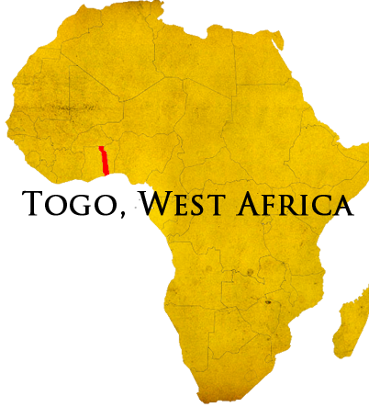
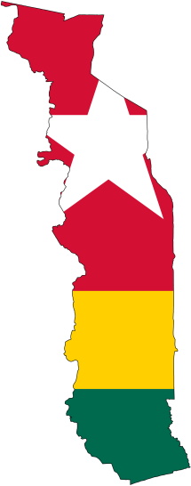
Dec 2020
Jonathan and Bethany Edwards
Using Medicine and Technology to Grow Christ's Church

Making Disciples in Muslim Mango, Togo and Beyond

The people who walked in darkness
Have seen a great light;
Those who dwelt in the land of the shadow of death,
Upon them a light has shined.
For unto us a Child is born,
Unto us a Son is given;
And the government will be upon His shoulder.
And His name will be called
Wonderful, Counselor, Mighty God,
Everlasting Father, Prince of Peace. – Isaiah 9:2 & 6
Happy belated Thanksgiving and Merry Christmas to all of you!
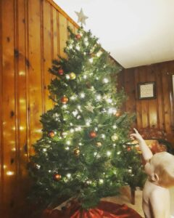
It seems everyone we talk to feels the same way — beyond ready for this holiday season after such a difficult year! Like many of you, we decorated a little earlier and have found the Christmas carols stuck in our heads sooner than expected. We’re thankful that our hope in Christ is unwavering and not dependent on the circumstances in this unpredictable world. Despite the differences in our celebrations and gatherings this year, we hope you are able to see this season afresh as we remind our heavy hearts of that joy and light Emmanuel came to bring.
We have said it before, but we want to again thank our partners for your patience and faithfulness during this uncertain time. As Paul wrote, we thank our “God upon every remembrance of you.”
Thank you also to those individuals who have shared your uplifting personal emails, notes, and spoken words over the last few months. They have all been special and encouraging to us.
We want to extend a special thanks to Cavel Baptist for hosting us for almost 10 months already and taking such good care of us from housing to spoiling Caleb with toys. It has been a huge blessing to have our Christian brothers and sisters looking out for us and providing a home equipped with furniture, dishes, appliances, and even Christmas decor and much more that would have been a hassle and expensive for us to find quickly.
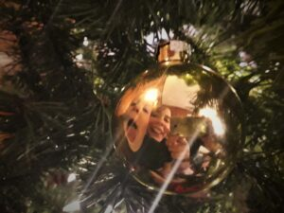
As for Jonathan’s health, there is not much new to report. He still has more energy and is doing much better overall than when we arrived in the US, and for that we are very grateful. His attending physician has told us that she considers him to be stable on his current medication regimen, and that he needs a minimum of six months of that stability to determine if healing is likely or if this is a long term issue. At this point, it is a game of wait and see. The good thing is that this process can take place concurrently with support-raising if need be – Jonathan’s energy allowing. With this time frame and other events taking place next year (see below), a return to Togo is unlikely before the end of May 2021.
In the meantime, he has started working with ABWE’s Live Global doing some stay-at-home tech work as his energy allows to aid the ministry of those partners around the world who need specialized expertise.
Caleb continues to thrive developmentally. He is talking more and more, and his level of comprehension takes us by surprise sometimes. A favorite pastime is exploring outdoors and getting as dirty as we will let him. He is one tough, brave, adventurous, and sweet little man who brings lots of smiles and laughter to our home.
However, he is in for a big adjustment around the end of April … Little Edwards #2 is on the way, which is another reason for our 2021 timeline. We are very thankful for another good gift from our Father and are looking forward to meeting him or her!

