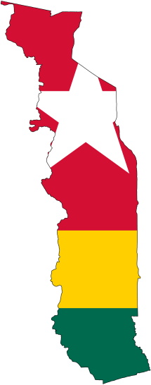
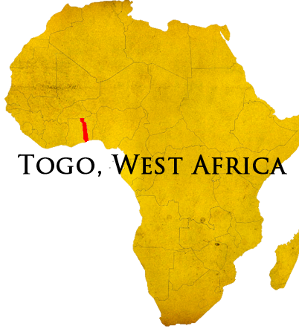
“I thirst for you, my whole being longs for you, in a dry and thirsty land where there is no water.” –Psalm 63
Dry season here lasts for eight months. The wells go dry and the Oti River runs low. The Hospital of Hope and city of Mango both depend on the river for water. As that source dries up water supply becomes an issue as has been the case several times already. We are searching for long-term solution for water problem. Recently the team tried drilling two more wells – both dry. We trust that God will provide despite our disappointment and frustration in diligently searching for a solution. Thank you to all who have been praying. Please continue to pray for a long-term answer.
This area is dry spiritually. Islam, Fetishism, and false Christianity are everywhere. The gospel message is like clean, cool, refreshing spring water. Hospital of Hope recently registered its 5000th patient. At this rate it'll be 20,000 in the first year alone. And we're just getting started! Almost all of these patrons have heard God’s message of hope and some heard about God for the first time - although some refuse. It is exciting to see the many ways that God is beginning to work in the people of this community (For safety reasons I will not write of them here. You may ask me in person.)
My year here has been a good opportunity to learn and answer many of the unknown questions about what Information Technology ministry looks like in and around Togo. As my time nears an end the staff are transitioning to handling most of the responsibility. I will continue to support both facilities from the US as much as possible and in some way will be better able to communicate with software developers on how to improve the computer systems solicit donations, and arrange for donated equipment to be shipped.
So the two big questions, when will I be back and what do I plan to do? You might see me around some time in August. Why so late? This is because I will be Harrisburg for the first steps toward full-term service in Togo, specifically
330-601-3750
www.elusivetangent.com

jedwards@abwe.cc
Contact Info
Prayer Requests
For a solution to the hospital’s ongoing water supply problems.
Transition back to the US and starting with long-term requirements.
June 2015
Reaching...
Teaching...
Connecting...
Directing...
Jonathan Edwards

IT Manager
with an expanded ministry of what I am currently here doing. This will include several weeks of training and some time to visit with friends and family. Following that, I will begin prefield and raising support.
It’s an exciting time to see God working in so many ways to bring this about and I am excited to see the continuation of His work here! Please pray for me during this transition.
I hope to see you soon in person.

