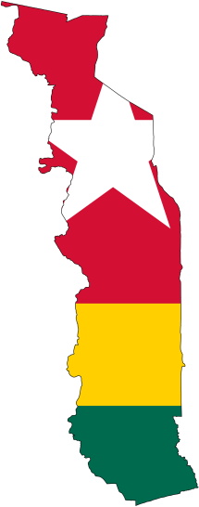

Welcome to Hôpital de l’Espérance! The hospital in Mango officially opened on March 2nd with much international fanfare. 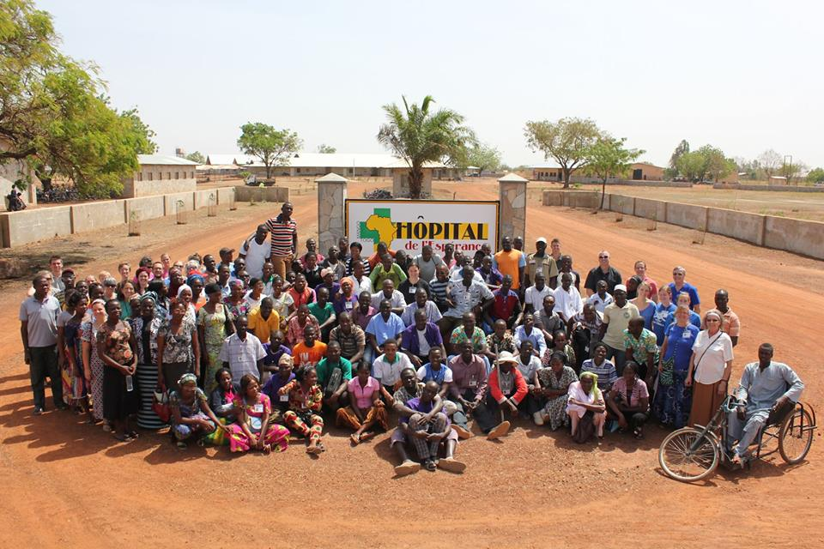
The month passed since opening has been one of transitions. The workers are doctors instead of bricklayers; the work has changed from building structures to making disciples. Thousands of people have been treated and as many as were listening have heard the message of God’s good gospel. Most people hear this message for the first time through any combination of our doctors, nurses, chaplains, and the Jesus film. Despite the many reached the need is so great that many more have been asked to return another day because we simply don’t have the capacity to care for everyone in the daily arrivals. Truly, the fields are white for harvest. Join us in praising the Lord our God daily for so many opportunities to share His good news and praying that He will provide for the continued work here. Our team and specifically the church planters continue to invest in discipling local men and women to be ministers and leaders for fledgling local churches.
The computers have had their share of difficulties as can be expected from a new facility. We had a fun moment recently when the main server room
330-601-3750
www.elusivetangent.com

jedwards@abwe.cc
Contact Info
Prayer Requests
Pray for God to raise leaders for churches.
Pray for the spread of the gospel through the hospital, Hope radio, and other ministries.
Pray for unity and missional spirit for local churches and church leaders.

Spring 2015
Reaching...
Teaching...
Connecting...
Directing...
Jonathan Edwards

IT Manager
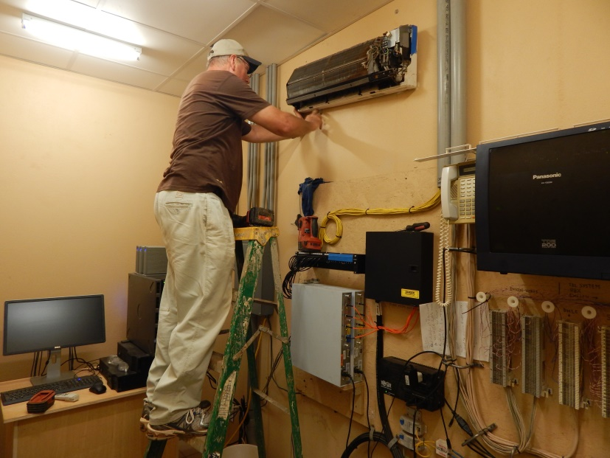
that is the nerve center of the hospital system had a water leak and water was splashing on network switches and pooling on the floor. An air conditioner hose had become blocked and was draining into the room rather than outside. Praise the Lord that no equipment was damaged! Poor electricity provided by the city utility, ever present dust, and ubiquitous heat only add to the needed maintenance and significantly reduce the expected life of computers. Such is the reality of working in West Africa. Even so, we praise God for the great work He is doing here with us and through us.

Schools’ Mobile Computer Lab
Another exciting ministry that I mentioned previously is providing a mobile computer lab for the Baptist run Christian schools throughout Togo. Sixteen laptops were donated to set up a pilot project. First, thank you to everyone who helped to organize and ship these donations. They are almost ready to be delivered.
These computers will give students the opportunity to learn about technology that is otherwise out of reach. Many students even at the college level never have access to technology and this limits them when seeking employment. I will be working with the missionaries Andrew and Mary Ward and Christine Sopcisak along with school administrators to finalize these plans. The mobility of laptops allows this lab to be shared between the schools, eliminates the need for costly permanent room needed for a permanent lab, and allows it to be taken to a secure location each night. We are excited to offer this extracurricular activity to further share the gospel with the students and help them gain valuable life skills.
Now that the hospital is opened I will begin to transition into more of a managerial role and allow the techs to pick up the majority of the daily technical work. This is a needed step to get them accustom to the idea of working mostly independently. I will continue to set the direction, handle policies, coordinate and handle major equipment upgrades, advise the administration, and tackle anything complicated and urgent. I will also focus more on discipling those I work with directly.
Serving our King,
Jonathan

