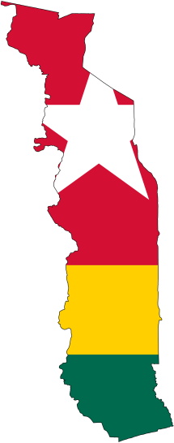
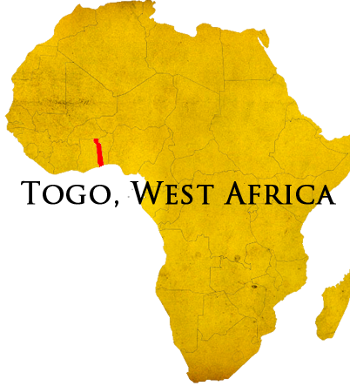
It has been a long two months since the last update and much has happened - a trip to Mango, a trip to Lome, new toys, and a developing ministry opportunity.
Mango.
At the beginning of September Bill and Nathan, the technology nerds from ABWE headquarters, came out to Togo to help in the setup of Hopital de l'Esperance. And set up we did. Networking equipment was unpacked and plugged in even as another team was running the wiring. Phone lines were tested. The main servers (the computer brains that runs the hospital systems) were set up and final configuration done. Workstation computers were unboxed, test, and reboxed. All said, the trip did everything but sit the computers on the desks. They remain packed safely in boxes away from dust and construction hazards until closer to opening day.
HBB, Lome, and new toys.
A week after returning from Mango Anani and I visited Lome to buy ten new workstation computers for HBB. Buying anything in Lome is always an adventure and this time was no different. We arrived at the computer shop that had assured us by phone that they were able to get the computers in the amount we needed. But when we got there, they had only one. Frustrated, we called up another merchant who had what we needed... but then we had to renegotiate the price, return policy, and warranty – none of these come standard in Togo. Finally with the goods in hand we returned to HBB.
Unfortunately, next day both Anani and I were extremely ill and spent the next week recovering. He managed to return to work in six days. It took me another week. (Thank you everyone who prayed for my speedy recovery.)
In the comings weeks we will be setting up these new computers in preparation for training on the new hospital software expected to be ready in November. Even with the purchase of these new computers we are still seeking bulk computer donations. Please pray with us that an organization would provide the equipment or the funds to buy equipment for the twenty-five remaining computers that desperately need replaced.

330-601-3750
www.elusivetangent.com

jedwards@abwe.cc
Contact Info
Prayer Requests
For God’s provision of additional equipment and shipping funds for HBB and Christian schools’ computer labs ministry technology.
For wisdom in the development of the Christian schools computer labs ministry.
For insight as I continue to learn how to “do life” in Togo and make decisions about long-term ministry here.
October 2014
Reaching...
Teaching...
Connecting...
Directing...
Jonathan Edwards

IT Manager

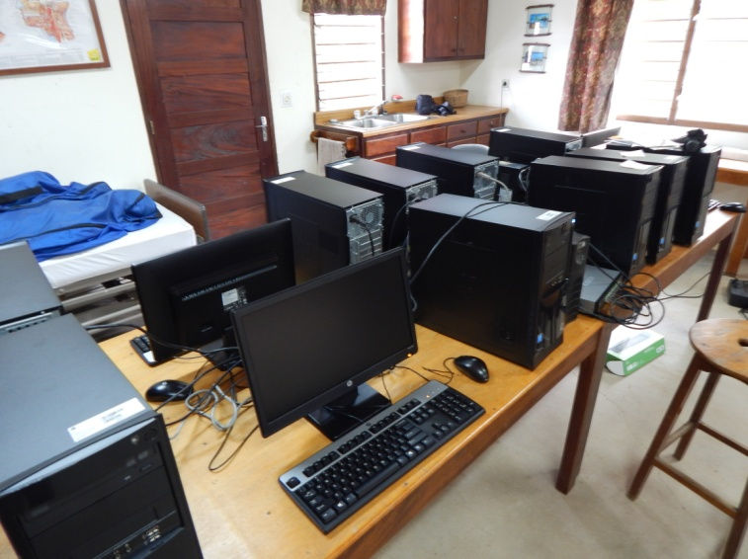
Last week it was also announced that the opening date for Hopital de l’Esperane has been delayed from the January 8th to March 2nd. Because of this, there has been a change of plan for when I will be moving north and for how long. Training will still require that the whole computer system be set up by December. I will make a short trip for this and then return to Tsiko until mid-February.
A New Ministry Opportunity.
Several months ago I met with missionaries and administrators of Christian schools throughout Togo about the possibility of setting up computer labs and their vision of technology’s future in schools. At the time this was only wishful thinking because there were no computers and no money to buy or ship them. We commited it to God that if He wanted to start this type of ministry that He would send the supplies. (Many of you have been praying for the provision of this equipment.)
Configuring the new computers for use at HBB.
The Christian schools are run as a joint ministry between missions agencies and the local churches. There are fourteen campuses throughout southern and central Togo serving over three thousand students with expectations to expand as new churches are able to come on board. Christian schools provide high quality education with a Christ-centered emphasis to Togolese students. The quality and reputation of the schools is such that even Muslim families will enroll their children – who then here the gospel and take it home. However, technology is something that has been out of reach for the budgets of these schools... or any K-12 school in Togo.
Recently, sixteen donated laptops were shipped and are due to arrive late November. We plan to use these laptops to set up a mobile lab travelling between the different schools. This mobile lab will serve as a pilot project before pursuing permanent labs at each school. Using computers at these labs, student will are able to use computer aided learning programs, gain understanding and worldview through (filtered) access to internet communities, and get valuable exposure to technology from a young age that will help them compete as equals in a global marketplace. All of this will only add to the value and reputation of these schools drawing more students who will receive gospel focused teaching.
We’re excited to see what God is doing. We ask that you would pray with us for guidance and that God would provide financially and through donations to develop this ministry.
Your continued prayers are always coveted.

