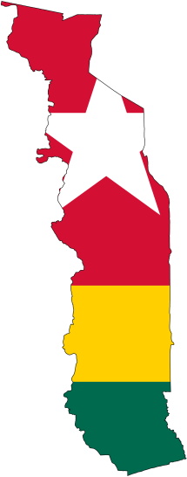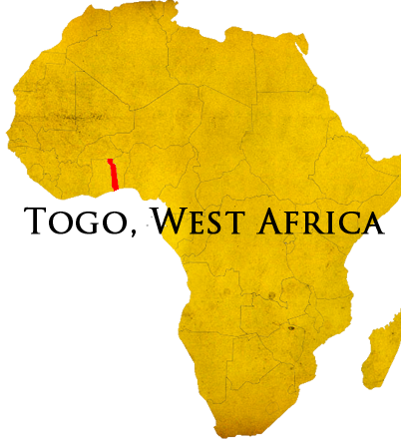

July came and went and it seems like much longer than two months since I first was planted in Togo. Much has happened since then and even more is going to be happening in the coming weeks.

I was able to take my first trip to Mango. It was a quick survey trip that allowed me to observe the progress of the compound as well as learn about some of the unique difficulties in regard to technology in the region – and there are many unique challenges from dust and heat to lack of available parts to untrained personnel. I was also able to learn about the people and their (much different) culture and spiritual need. Truly, this new hospital will be a well of living water to peoples thirsty for the Living God.

I used the month of July mainly to adjust and observe – learning the culture and figuring out how to “do life” in Togo. Those weeks have been beneficial as I begin to plan out changes needing to be made to reach a vision of HBB with proper technology.

I have been mentoring Anan, an IT technician at HBB, in the proper setup and maintenance of computer systems, especially preventative maintenance, rather than following the cultural norm of not fixing it until it’s broken... and then only fix it until it works again. Over the coming months we hope to implement policy changes and plans to help extend the lifespan of the technology here and guide the technology to best help the staff.

In August, there will be meetings about many of the projects that will set vision of HBB for several years to come. These meetings will include several major technology projects. A highlight of these include setting up the hospital wide EMR software, acquiring and setting up new computers, reliable internet, and staff training for the new system. Please pray with us that God would give wisdom to me and the administrators in these decisions, that God would provide the computers that are needed to run the software and train the students, and for help as we negotiate with telecommunications companies to find a reliable internet connection.

330-601-3750

www.elusivetangent.com

jedwards@abwe.cc

**Contact Info**

Prayer Requests

For wisdom in planning HBB’s technology future.

For material resources of computer s and equipment to run the facility and train staff.

That God would use us to proclaim His message of hope to many more people throughout the region for His glory!

**August 2014**

**Reaching...**

**Teaching...**

**Connecting...**

**Directing...**

**Jonathan Edwards**

IT Manager