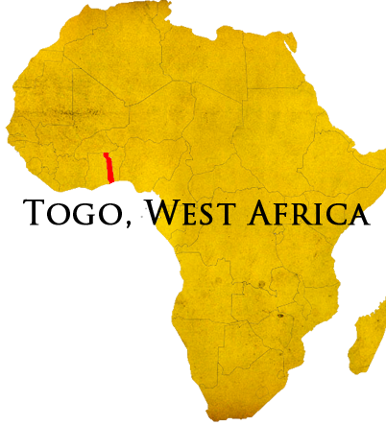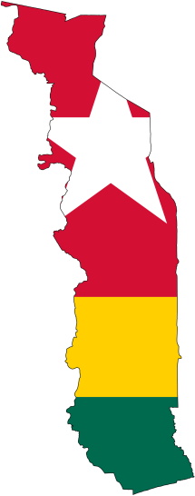

Support Level

90%

Prayer Requests

That God would raise up partners for the remaining 10% support.

That God would work to provide standardized, updated computer equipment for HBB (southern hospital).

That all the arrival details will come together

330-601-3750

www.elusivetangent.com

jedwards@abwe.cc

**Contact Info**

**Reaching...**

**Teaching...**

**Connecting...**

**Directing...**

**May 2014**

**Jonathan Edwards**

IT Manager

The plane tickets have been purchased! I am excited to have the travel plans worked out. In my last update I had said that the departure date might be early July. As it turns out, God wanted it near the original mid-June date. He provided for reasonably priced tickets on June 18th. That's so near you can count down in hours.

Along with this comes another progress marker. Several other partners have joined to bring my support level to 90%. Wow, to be so close and yet know that there are only weeks to raise the remaining 10%. However, being at 90% support, ABWE has given financial clearance to leave another important step.

I am now working closely with the field team to arrange the details for transport, board, and visa once I arrive. My remaining weeks will be making arrangements both on-field and in the US as I transition and organizing and packing everything I need including supplies that other missionaries have requested I transport for them. I have been taking IT contract work so explaining to my supervisor why I am leaving his employ is a non-issue.

Even in the midst of preparing to leave, I have been working to get a large donation of computer equipment for HBB. This equipment would make a huge difference in the day-to-day running of the hospital, the training of staff, and the equipping of church leaders and local believers. I have provided the donor with a list of specific equipment needs and quantities. The response has been positive thus far. Please join with me in praying that we will receive even beyond what has been asked according to His promises.

Thank you for all of your prayers and support.