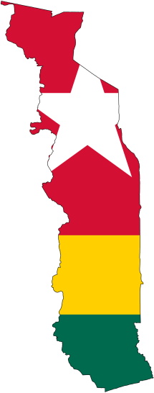

**Support Level**

91%

**Prayer Requests**

Cultural and language adjustment

Wisdom in advising HBB administrators and implementation of work plans.

Better and affordable IT equipment for the facility.

330-601-3750

www.elusivetangent.com

jedwards@abwe.cc

**Contact Info**

**Reaching...**

**Teaching...**

**Connecting...**

**Directing...**

**June 2014**

**Jonathan Edwards**

IT Manager

I have arrived safely in Tsiko, Togo. The plane landed late Thursday night after a long but uneventful series of flights and I was picked up by a hospital chauffer and driven to HBB Friday after errands in Lome. Over the weekend I started learning the ins and outs and the does and don’ts of life here. I am already excited to see the amount of good work that is done here at HBB.

The language is, as expected, somewhat of a barrier. Even though I began learning French months ago basic conversations are still difficult. This is because of the difference in semantics and the cultural phrases used. Even when I understand the words spoken, the expression often makes little sense. This is something that must be learned in any new region and I’m excited for what my Togolese friends can teach me.

The culture here is very different and it will take time to adjust – much more so than language. Thankfully, the other missionaries and the Togolese staff are very gracious and helpful in teaching when I do make mistakes.

It is clear now just how much work there is to do here and how resources are available to do it. Another short-term missionary has been here for a month assessing the situation and setting up initial work plans. I praise God for the work he has done and the transitional ease that will give.

Please continue to pray that God will bring up more supporters. The work needed here well exceeds the year that I expect to stay and currently my support level will not permit me to stay even that long. If I reach 100% support then I will be able to stay an entire year and possibly longer if it exceeds 100%.

Thank you for your continued prayers,

Jonathan