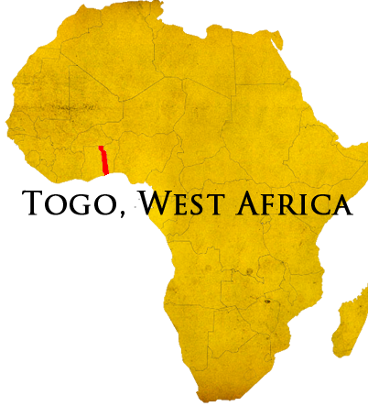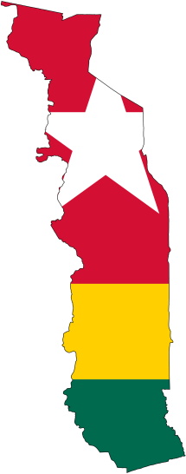

Support Level

79%

Prayer Requests

For God to bring more churches and families to bring support to 100%.

God's guidance and blessing while preparing the final details of departure.

God has worked marvelously in the past months. I have had the opportunity to present my ministry to many people both individually, families, and in churches. It is always a blessing to share what God is doing with others.

It is exciting as my expected departure date moves slowly nearer how God is providing for the details. Even so, my departure date, which previously had been set for mid-June, is now looking to be the first week of July. The departure time is not longer measurable in months, but weeks. Soon I expect to be packing bags and heading to the airport... but there is much to do until then.

I praise God for those who have helped thus far by listening, sacrificed time, services, or materials, and offered guidance. Togo is full of spiritual battles and the devil would seek to destroy the good work God has called many of His servants to do there. We are all part of one body and if one part suffers, all are affected. Therefore, I am thankful for the strengthening of Godly men who stand beside me and teach and strengthen.

"The grace of our Lord Jesus Christ be with you."

330-601-3750

www.elusivetangent.com

jedwards@abwe.cc

**Contact Info**

**Reaching...**

**Teaching...**

**Connecting...**

**Directing...**

**Mar - Apr 2014**

**Jonathan Edwards**

IT Manager