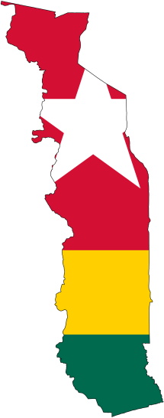

330-601-3750

www.elusivetangent.com

jedwards@abwe.cc

**Contact Info**

Support Level

60%

**Reaching...**

**Teaching...**

**Connecting...**

**Directing...**

**Jan - Feb 2014**

**Jonathan Edwards**

IT Manager

These last two months have been a full of opportunities to minister and be ministered to by churches and individuals who were willing to hear God's mission for me. It has been great to get to know God's family and the welcoming care they extend. This has been such an encouragement. What other community in the world can take in a stranger and treat them as family like Christians do. Indeed, it is good to be in the house of the Lord with brothers and sisters in the faith - a hospitality that extends through me to the Togolese so that they, too, will share in that same fellowship and love.

**Pressing Toward the Goal...**

My support level is now at a solid 60% even after some changes to the budget and the yearly inflation adjustment. This is a huge blessing and gift from God to be able to reach over half way in less than three months. Even so, the remaining forty percent requires partnering individuals, churches, and organizations to provide the remaining support so that God's word can go forth to the people groups of West Africa.

It's hard to believe that in four short months, Lord willing, I will be on a jet plane headed for Togo and much remains to be done before then. Logistics details such as packing, knowing what equipment and parts to take and what to leave behind need to be sorted. When does an item need to be there? Can it go in on a container ship or should it go by air? Are all immunizations and passports ready? Did practicing French find its way onto the schedule? Needless to say, the details add up. Partly, it seems a much larger task because it's not like forgetting your bible at church on a Sunday morning which I have a bad tendency to do. Instead, whatever is left behind is a world apart and will be days (or months) before it gets back to me. But the Lord will provide, and there is time to sort out these details.